Halo Continuity Light Spine
White Paper Proof of Concept for CPSS-Backed Emergency Utility Continuity Through the Halo Transit Spine
Document Type | Emergency spacecraft continuity-power proof-of-concept white paper
Concept Thesis | Use distributed CPSS reserve nodes as a crystalline emergency energy layer and route them through the Halo Transit Spine as a segmented internal utility backbone for critical systems continuity after main-plant failure.
Primary Use | Emergency lighting, life support continuity, navigation, communications, thermal management, and selective internal mobility support
Status | High-level concept architecture draft
Abstract
Halo Continuity Light Spine is an emergency-utility architecture that combines distributed CPSS reserve nodes with the segmented Halo Transit Spine to preserve critical ship functions after a major power loss. In this concept, CPSS acts as the adaptive reserve and energy-conditioning layer, while the Halo Spine provides a protected internal routing trunk capable of isolating faults, maintaining continuity through surviving sections, and feeding a priority bus for mandatory systems. The phrase 'continuity light' is best understood as the visible or field-like presence of this emergency state: the ship is not fully powered, but it remains alive, lit, and coordinated enough to survive. This is not a claim of full-power restoration. It is a doctrine of graceful degradation through distributed reserve energy and disciplined internal routing.
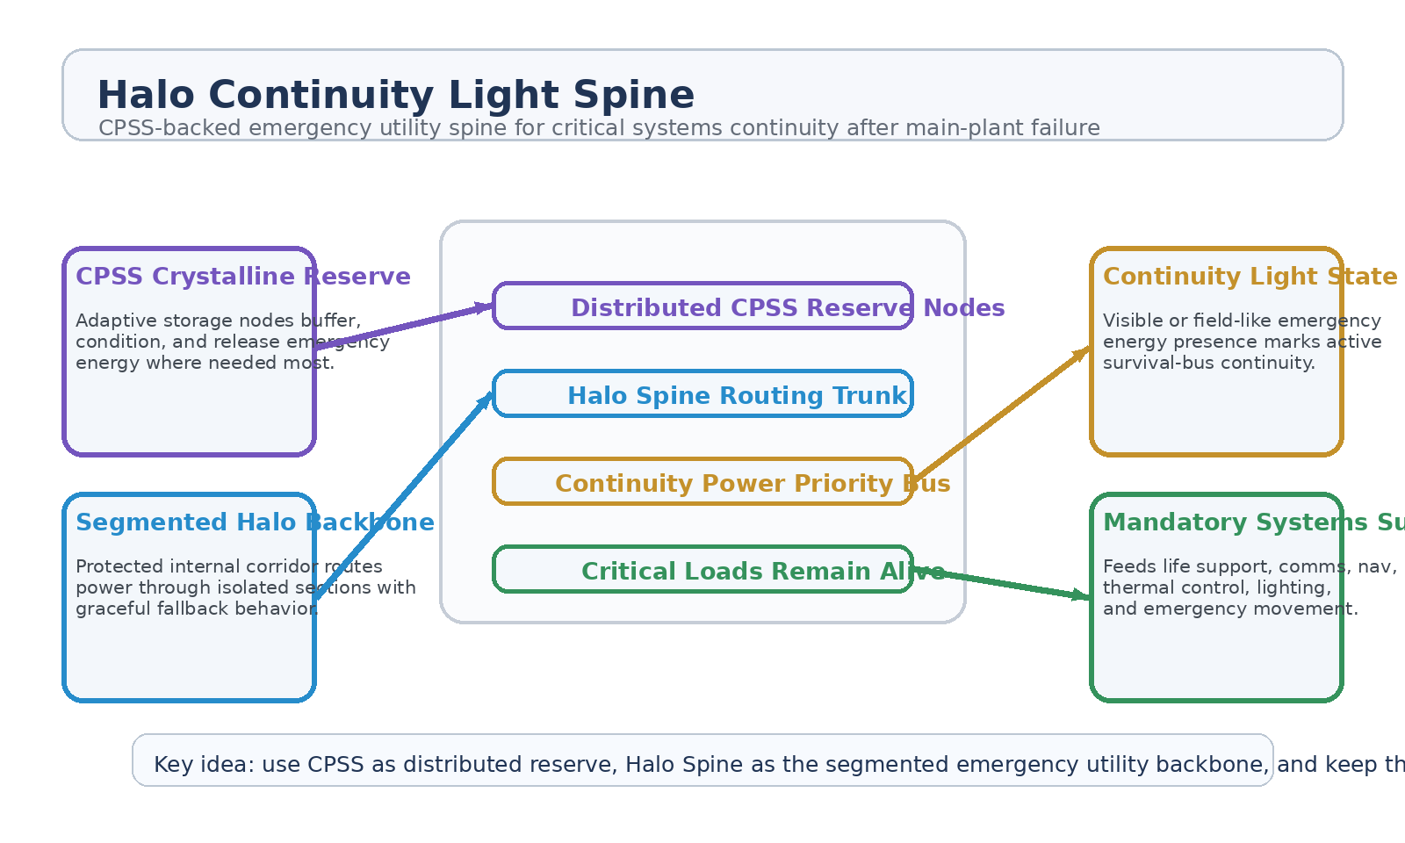
Figure 1. Halo Continuity Light Spine with CPSS reserve nodes, Halo routing trunk, continuity priority bus, and critical load support.
1. Concept Thesis
The core idea is to treat the ship's internal mobility spine as a second life when the main plant fails. Halo Transit Spine already provides a segmented, synchronized, protected internal architecture. CPSS already provides a field-tunable reserve and distribution medium. Together, they form a credible emergency utility layer: reserve energy lives in distributed crystalline nodes, while the spine becomes the internal trunk that keeps those nodes connected to the systems that matter most.
This means the vessel does not go from bright to dead in one event. It falls back into a continuity-light state.
2. Why These Concepts Fit Together
The Halo Transit Spine papers define the spine as a managed internal backbone with segmented domains, safe-hold behavior, and graceful fallback under faults or interruptions. That makes it a strong candidate for more than movement alone.
The CPSS brief defines an adaptive storage medium whose conductivity and release behavior can be tuned in real time. That makes it unusually suitable as a distributed emergency reserve embedded through the vessel.
The combined claim is modest: use the spine for internal continuity routing and use CPSS for reserve energy and local stabilization. The result is not infinite backup power. The result is a ship that fails more slowly and more intelligently.
3. System Architecture
Layer | Subsystem | Primary Function | Continuity Role
L1 | Distributed CPSS Nodes | Store, buffer, and condition reserve energy in multiple ship sections. | Emergency reserve layer
L2 | Halo Spine Routing Trunk | Provide segmented protected routing through the ship interior. | Continuity backbone
L3 | Priority Utility Bus | Rank and feed critical systems before nonessential loads. | Selective survivability
L4 | Continuity Light State | Maintain visible/emergency energy presence and coordinated low-power operation. | Failure grace state
L5 | Critical Loads | Life support, comms, nav, thermal control, and emergency movement support. | Ship stays alive

3.1 CPSS as Crystalline Reserve
CPSS is strongest here as a distributed reserve and conditioning layer. Its adaptive conductivity and modular deployment make it suitable for local emergency energy support in separated ship sections. This allows the vessel to preserve useful pockets of power instead of suffering a single global blackout.
3.2 Halo Spine as Utility Trunk
Halo Transit Spine is best reinterpreted here as a protected internal utility corridor in addition to a mobility structure. Because it already uses segmented domains, synchronization logic, and graceful fallback, it naturally supports the idea of routing continuity power through surviving sections of the ship.
3.3 Continuity Light State
The 'continuity light' phrase should be treated as operational doctrine, not mystical overclaim. It describes the state in which the ship is no longer fully powered but still visibly and functionally alive: emergency lighting remains on, the command network remains coherent, life support continues, and critical subsystems still receive enough routed energy to operate under survival conditions.
4. Mission Roles
• Emergency lighting and habitat continuity after major power loss.
• Life support, comms, and navigation survival routing.
• Thermal-management support during degraded reactor conditions.
• Selective medevac or utility mobility support through surviving spine sections.
• Compartment-by-compartment continuity in large ships where total blackout would be catastrophic.
5. Why This Is Stronger Than Simple Backup Cells
• Uses distributed reserve nodes instead of one vulnerable backup bank.
• Routes energy through a segmented internal trunk with fault isolation.
• Allows the ship to remain coordinated in surviving sections even after major failure.
• Treats emergency power as a living internal bus rather than a dumb spare battery.
• Supports graceful degradation instead of all-at-once blackout behavior.
6. Boundaries and Realism
Halo Continuity Light Spine is strongest as a continuity-power architecture, not as a claim that CPSS or the Halo Spine alone can fully replace the main plant. The system is about buying time, preserving order, and supporting survival-critical loads. Its value lies in making failure slower, smarter, and more survivable.
• Most credible as an emergency utility and continuity doctrine.
• Not a substitute for full primary generation.
• Limited by CPSS reserve size, routing integrity, and surviving ship sections.
• Best used to preserve life, command, and internal coherence rather than normal mission output.
7. Operating Modes
Mode | CPSS Behavior | Spine Behavior | Outcome
Reserve Hold | Nodes remain charged and locally conditioned. | Spine routes only health-check and standby continuity signals. | Emergency readiness
Continuity Light | CPSS feeds emergency bus through surviving sections. | Spine prioritizes lighting, life support, and command functions. | Ship remains alive and coordinated
Compartment Survival | Local nodes isolate and support damaged sectors independently. | Spine seals off faulted domains and preserves clean sections. | Partial ship survival
Recovery Escort | Remaining reserve is rationed to medevac, comms, or utility movement needs. | Spine supports controlled low-power transit and routing. | Longer rescue window

8. Proof-of-Concept Build Path
Phase | Goal | Bench / Program Activity | Success Signal
P1 | Reserve-node baseline | Demonstrate distributed CPSS-like reserve behavior across multiple isolated sections. | Stable reserve distribution
P2 | Spine continuity routing | Use a segmented internal trunk to route low-power loads around a faulted section. | Graceful reroute
P3 | Priority bus logic | Rank mandatory and nonessential loads under declining reserve conditions. | Correct shedding behavior
P4 | Continuity-light state | Demonstrate that lighting, comms, and life-support surrogates remain active in degraded mode. | Visible emergency survival state
P5 | Compartment survival test | Simulate plant failure and compare total blackout against continuity-spine operation. | Longer ship survivability window

9. Conclusion
Halo Continuity Light Spine reframes internal mobility infrastructure as a survival-utility organ. CPSS provides distributed reserve energy. The Halo Spine provides segmented routing and graceful fallback. Together they keep the ship lit enough to survive, coordinated enough to respond, and stable enough to buy time after the main plant fails.
As a white paper PoC, the concept is strongest when treated as a doctrine of graceful survival: not total power restoration, but enough continuity to keep the civilization inside the ship from going dark all at once.
Working one-line doctrine: Use CPSS as distributed reserve, Halo Spine as the segmented emergency utility backbone, and keep the ship lit enough to survive instead of pretending full power still exists.

